Lesson 6 – Using Subqueries to Solve Queries

Before starting ask the question

🡺 Give me a list of all employees that earn more than Haas

What is the SQL logic?

OBJECTIVES

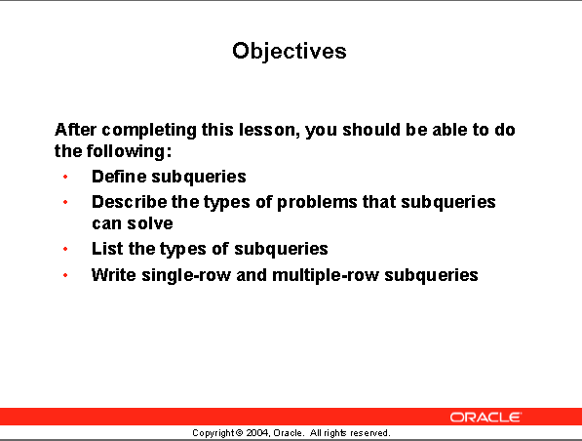

After completing this lesson you should be able to do the following:

🡪 Define subqueries

🡪 Describe the type of problems that subqueries can solve

🡪 List the types of subqueries

🡪 Write single-row and multiple- row subqueries

This chapter covers the more advanced features of the SELECT statement.

You can write Subqueries in the where clause of another SQL statement to obtain values based on an unknown conditional value.

This chapter covers single row subqueries and multiple row subqueries.

6-3

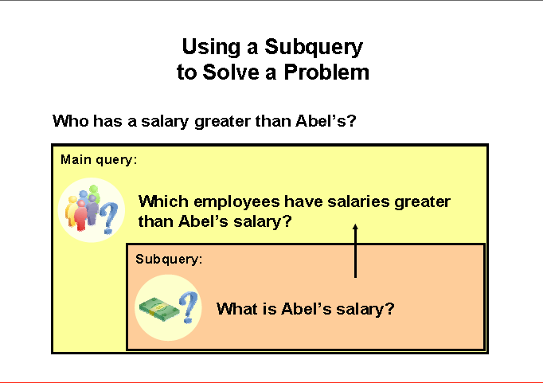

# Using a Subquery to solve a problem

## Problem:

**Who has a salary greater than Abel’s salary?**

## Solution:

**2 steps**

🡪 Find out how much Abel earns

🡪 Find out who earns more than that amount

That requires two queries. We need to pass information from the first query into the second query.

Writing two separate queries does not do that.

We need is Subquery define Abel’s salary and pass it to the main query that produces the results.

6-4

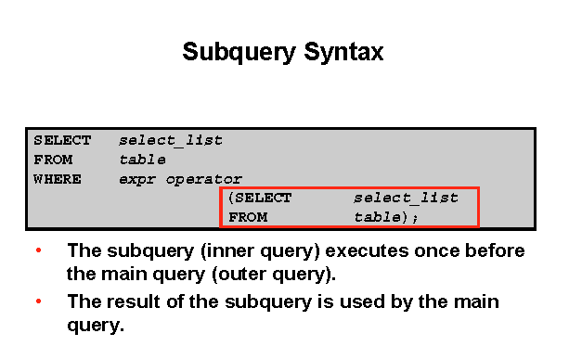

# Subquery Syntax

A Subquery is a SELECT statement that is imbedded in a clause of another SELECT statement.

Useful when you need to select rows from a table with a condition that depend so on data from the same table or other tables.

## Where used

On the following clauses:

🡪 WHERE clause

🡪 HAVING clause

🡪 FROM clause

**NOTE:** operator means

Single-row operator < > = etc.

Multiple-row operators IN, ANY, ALL

**OTHER TERMS USED**

Nested SELECT

Sub-SELECT

Inner SELECT

**ORDER of OPERATION**

The Subquery generally executes first and its output is then the fed to the main or OUTER query.

6-5

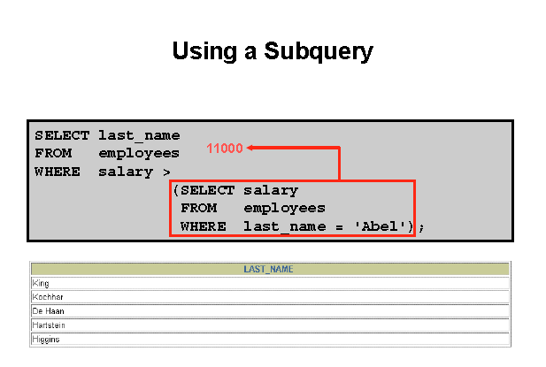

The above slide shows how we solve the problem who earns more money than Abel.

Note that the Subquery executes first and returns the value 11,000.

The outer or main query then executes with the 11,000.

It will supply all employees with a salary greater than 11,000.

**ASIDE**:

A better example would be to show the salary in the output.

6-6

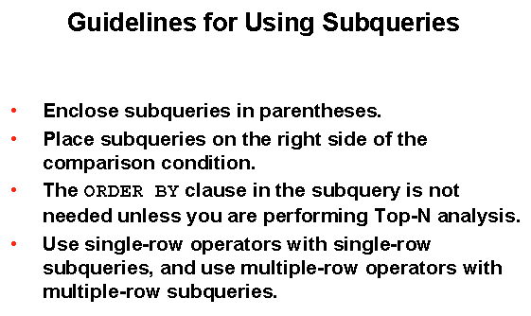

**Guidelines for using Subqueries:**

🡪 A Subquery must be enclosed in parenthesis.

🡪 Place the Subquery on the right side of the comparison operator for readability

You can do it the other way

***SELECT * from employees***

***WHERE (select salary from employees where last_name = 'Abel') < salary***

🡪 ORDER BY clause in the Subquery is only needed when performing TOP-N analysis

- Normally the order by clause is only found at the end of the SQL statement.

- TOP-N analysis refers two finding the top number of rows.

- Example top seven salaries

🡪 2 types of Subqueries are used:

Single-row operators

Multiple-row operators

6-7

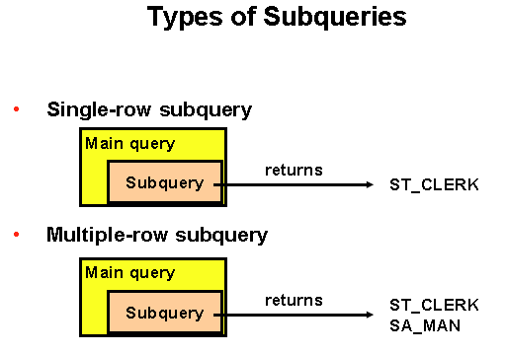

**Types of Subqueries**:

This slide shows the two types of Subqueries.

- Single-row Subqueries that return only one row from the inner SELECT statement

- Multiple-row Subqueries return more than one row from the inner SELECT statement

**Special note:**

**There are Subqueries that return multiple columns. These are covered in a later course.**

6-8

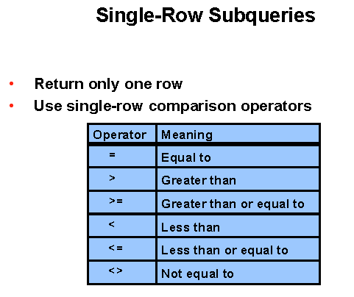

**Single-Row Subqueries**:

For single row Subqueries that return only one row from the inner SELECT statement, single row operators are used.

NOTE: you cannot use an equal to operator when you are comparing something to multiple rows.

**PROBLEM:**

Display the employees whose job ID is the same as that of employee 141

**SOLUTION:**

First find the job ID for employee 141

Use that job ID in the where clause to filter out the employees with the same job ID in the main SELECT statement.

**WRITE THE CODE TO DO THIS SOLUTION**

Demonstrate by writing INNER query first

SELECT last_name, job_id

FROM employees

WHERE job_id = (SELECT job_id

FROM employees

WHERE employee_id = 141);

Note: I often write the inner or Subquery first to find what it returns, then I write the main query.

6-9

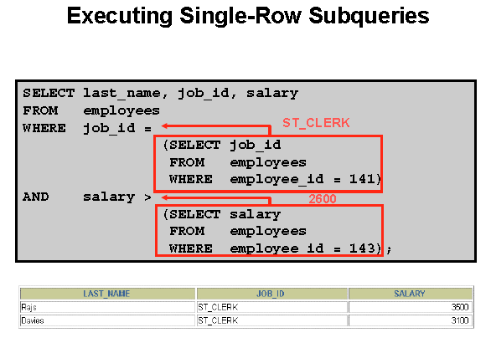

**QUERY BLOCKS**

A SELECT statement is often called a query block.

🡪 In the above example there are 3 query blocks.

The inner query block executes first bringing back the results ST_CLERK and 2600

The outer query block is then processed as if the WHERE clause was hard coded with those values that were returned from the inner query.

**NOTE:**

The Subquery can get information from different tables.

6-10

**PROBLEM:**

Display the last name, job ID, and salary of all employees whose salary is equal to the minimum salary of all employees.

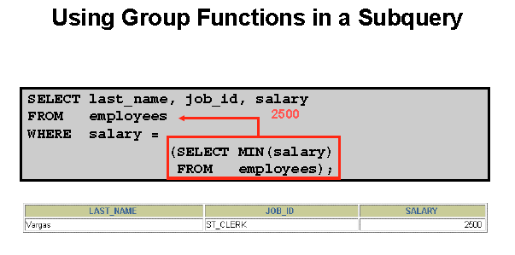

SELECT LAST_NAME, JOB_ID, SALARY

FROM EMPLOYEES

WHERE SALARY = ( SELECT MIN (SALARY)

FROM EMPLOYEES);

**Group functions in a Subquery**:

This example demonstrates that you can get information from the Subquery when the Subquery has a group function in it.

**SOLUTION:**

To solve this problem

First get the minimum salary of all employees from the inner SELECT or subquery period

Secondly, use the result in the main query

🡪 The inner query resulted in a minimum salary of 2500.

🡪 The 2500 replace the right side of the WHERE clause

SELECT LAST_NAME, JOB_ID, SALARY

FROM EMPLOYEES

WHERE SALARY = MIN (SALARY); 🡸 can’t use group function here

6-11

**PROBLEM 1**: Display all the departments WITH minimum salary greater DEPARTMENT 50 minimum

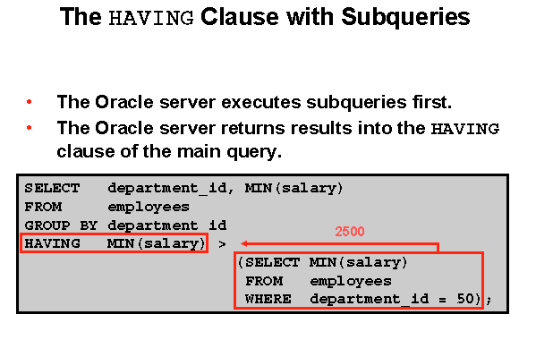

**Using Subqueries with the HAVING clause**

**SOLUTION:**

Step 1-The first query must use the group function to select the lowest salary in department 50.

Step 2-Since you want to find the minimum salary in other departments you need the group function in the main query.

Step 3-But you want to limit which groups are displayed. That requires a HAVING statement

Therefore the inner query is attached to the HAVING statement.

**PROBLEM 2:**

Find the job with the lowest average salary. Display the job ID and that average salary.

**SOLUTION: #1** Find the lowest average salary for a job ID

#2 Display that job ID and that average salary

SELECT job_id, AVG (salary)

FROM employees

GROUP BY job_id

HAVING AVG (salary) = (SELECT MIN ( AVG (salary) )

FROM employees

GROUP BY job_id );

6-12

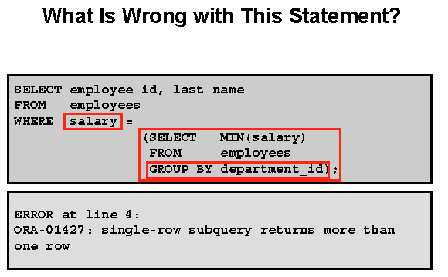

**Error:**

More than one row is returned – you cannot be equal to more than one value

When you use a GROUP BY there is an implication that there will be multiple rows returned. In this case the result of the Subquery is 7 rows returned. Each department ID in the employees table generated a minimum salary.

The outer query cannot be equal to seven different values.

SELECT department_id, employee_id, last_name, salary

FROM employees

WHERE salary IN (SELECT min (salary)

FROM employees

GROUP BY department_id)

*Change to IN*

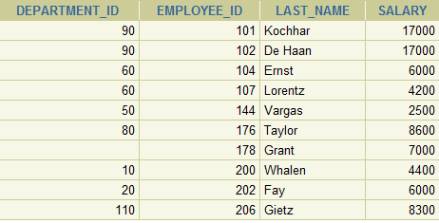

6-13

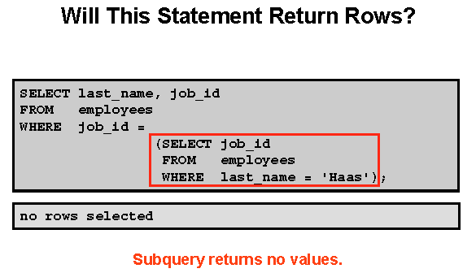

**COMMON PROBLEM:**

The above statement is correct. It didn't return any rows from the Subquery. (no Haas exists)

The query passes a **null** value back to the right hand condition on the WHERE clause.

There is no job ID that is equal to NULL.

Therefore no rows are selected

**SPECIAL NOTE:**

If there was a job ID with a NULL value then the left side value would be NULL, and the right side value would be NULL. This means that NULL would be equal to NULL and the row would be displayed.

For the row to be displayed, the WHERE clause must evaluate to TRUE

Because a comparison of two NULL values results in a NULL (instead of a 1 or 0) the WHERE condition is not true

**Getting a little harder …**

6-14

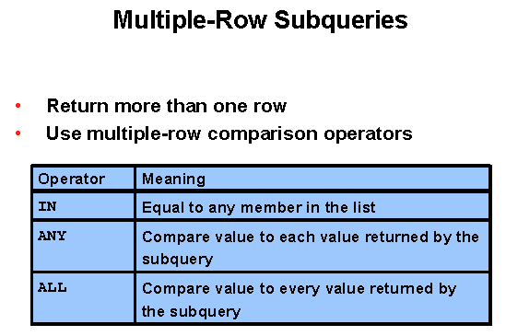

**Multiple-Row Subqueries:**

To use a Subquery that returns more than one row you need to use a Multiple-row operator

We did this before when we had a problem with the query.

We used the IN operator

SELECT department_id, employee_id, last_name, salary

FROM employees

WHERE salary IN (SELECT MIN (salary)

FROM employees

GROUP BY department_id)

6-15

**Problem**: Display employees with a salary less than people with job_id IT_PROG

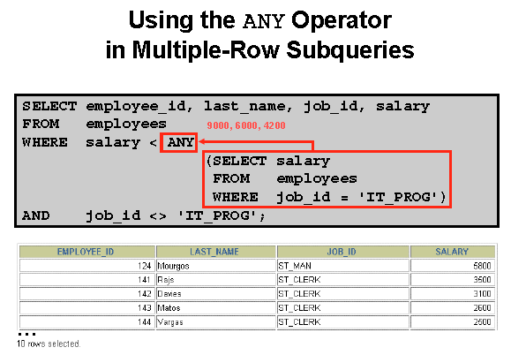

**Multiple-Row Subqueries:**

**ANY clause**

Looking at the outer query, the slide displays employees who are not IT programmers

**And**

whose salary is less than ANY salary that is returned by the inner Subquery

The inner Subquery sends back all the salaries for job ID equal to IT programmer.

The inner Subquery returns 3 salaries with values 9000, 6000 and 4200.

Since the outer query is looking for a salary **less than ANY** of the IT programmer salaries then it is looking for a value that is less than 4200 and less than 6000 and less than 9000. In other words, it is looking for a value less than the maximum value returned by the inner Subquery. The maximum value is $9000.

This will then return IT_PROG also unless the final line is added to the query

**NOTE:**

**< ANY** -- less than any will mean less than the maximum return

**> ANY** -- greater than any means more than the minimum value returned

**= ANY** -- equal to any is the equivalent of the **IN** operator

6-15

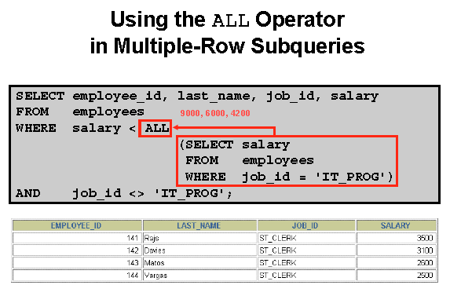

**ALL operator**

The all operator compares a value to every value returned by a Subquery.

The example on the slide displays employees whose salary is less than the salaries of all the employees that have a job_id of IT_PROG

AND

whose job is not the IT_PROG

Again there are three values being returned. They are 9000, 6000 and 4200.

🡺 To be less than ALL means you have to be less than 4200

**NOTE:**

**> ALL** -- greater than all means more than the maximum

**< ALL** -- less than all means less than the minimum

**NOTE:**

The **NOT** operator can be used with any of these. Caution is recommended the use of the not operator just as it was in other programming languages.

6-17

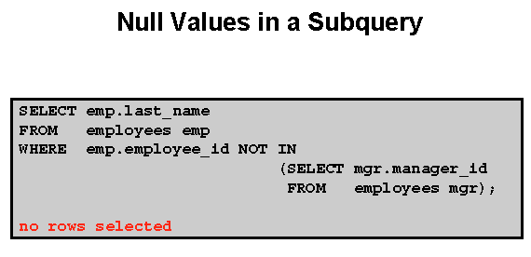

**SUBQUERY RETURNS NULL VALUES**

The subquery

SELECT mgr.manager_id

FROM employees mgr

Will return 20 rows, but one of the rows is NULL



**All conditions that compare a NULL value returns a NULL**

**NOTE**:

***IN works with NULLS***

SELECT last_name

FROM employees emp

WHERE emp.employee_id IN

(SELECT mgr.manager_id

FROM employees mgr);

**ASIDE:**

Did we need the ALIAS table names?

No, it was done for readability

**NOTE:**

*Could have added a WHERE clause in the Subquery 🡪 WHERE manager_id is NOT NULL*

**PRACTICE QUESTION**

Prompt the user for the employee last name. The query will return last name and hire date of any employee in the same department as the name supplied. Do not include the employee supplied.

What is the INNER query?

SELECT department_id

FROM employees

WHERE last_name = ‘&Name’

Enter ZLOTKEY and it will find nothing. Should use function UPPER

SELECT department_id

FROM employees

WHERE UPPER(last_name) = UPPER('&Name')

Now do the outer query

SELECT last_name, department_id

FROM employees

WHERE department_id = ( SELECT department_id

FROM employees

WHERE UPPER(last_name) = UPPER('&Name') )

Now eliminate the name entered

SELECT last_name, department_id

FROM employees

WHERE department_id = ( SELECT department_id

FROM employees

WHERE UPPER(last_name) = UPPER('&&Name') )

AND UPPER (last_name) < > UPPER ('&Name');

UNDEFINE NAME;